Project Name

Group Members

Index page

Problem Statements
Web
Command
Flag

Task Distribution
e.g
Web | Alina
Command | Mia
Filing | …..

Github

- All necessary images
- Link

WEB

- Web UI images
- Database Images
- All Necessary Images
- Source Code

Command

- Source Code
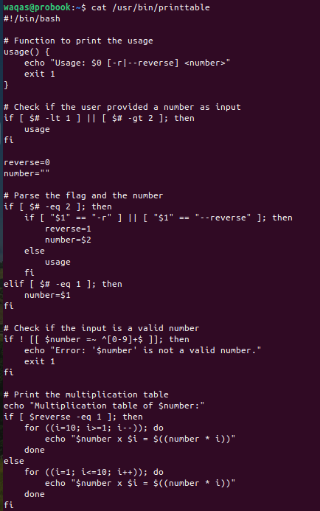

- File location
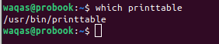

- Command implementation images
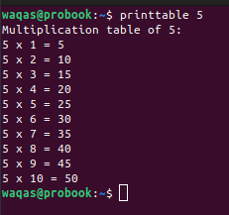
Flag

flag implementation images
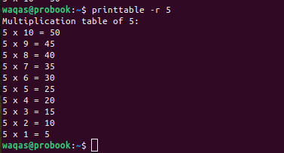

Note

Font Size
Main Heading
25
2nd Headings
20
Normal Texts
12
Font
Times New Roman

